Date: 26.03.2021
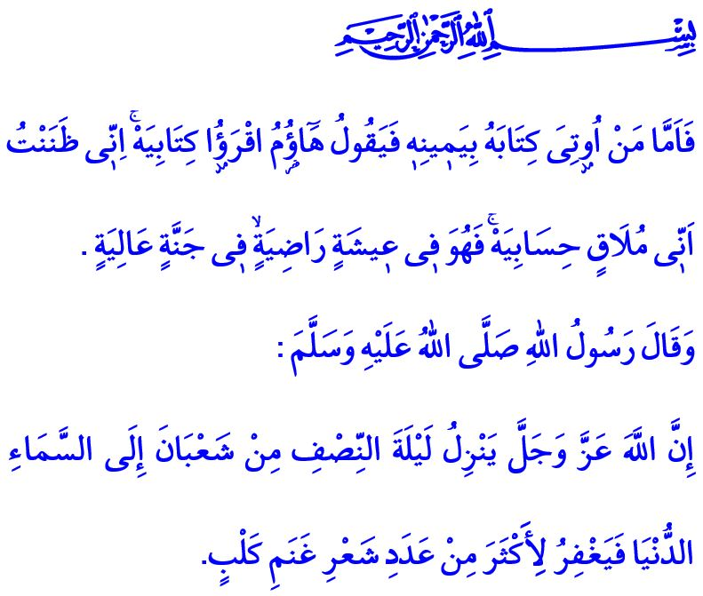
Lailat al-Bara’ah: Night of Forgiveness
Honorable Muslims!
The shadow of Ramadan al-Sharif, the sultan of the eleven months, is cast upon us now. Tomorrow we will welcome and enjoy the Lailat al-Bara’ah as the herald of Ramadan. May Allah the Almighty (swt) bless our great nation and the ummah of the Prophet Muhammad (saw) with prosperity and abundance of His (swt) divine blessings for the sake of the Night of Bara’ah. I wish you all a blessed Lailat al-Bara’ah.
Dear Believers!
It was some hour of the night like tomorrow, Aisha (ra) woke up and, when she realized that the Prophet Muhammad (saw) was not next to her, she went out to look for him. Finally, she found him, at al-Baqi’ Cemetery, with his head looking up to the sky and praying. In order to satisfy Aisha’s (ra) curiosity and tell her about how abundant the grace of Allah (swt) was that night, the Prophet Muhammad (saw) said, “Allah descends to the lowest Heavens during the night of the middle of Sha’ban and grants forgiveness to more than the number of hairs on the sheep of Banu Kalb.”
Dear Muslims!
In the Holy Qur’an, our guide to the true path, the state of those who are granted the warrant of eternal salvation in the Hereafter is stated as follows, “So as for he who is given his record in his right hand, he will say, “Here, read my record! Indeed, I was certain that I would be meeting my account.” So he will be in a pleasant life - in an elevated garden.”
We learn from these verses that in order to attain Allah’s (swt) pleasure and enter His heaven, we have to prepare for the Hereafter while we are still alive in this world, and live by faith and worship on the true path.
These special opportunities and months of barakah are times of contemplation to review our past and plan our future. Times of making up our mind to strive to live in line with the pleasure of our Lord (swt), other than with the unending desires of our self... Times of supplication and prayers to repent for our wrongs and sins, and to seek refuge in the forgiveness of our Lord (swt). In this regard, the Messenger of Allah (saw) makes the following recommendation for us, “When it is the night of the middle of Sha’ban, spend its night in prayer and observe a fast on that day. For Allah descends at sunset on that night to the lowest heaven and says: ‘Is there no one who will ask me for forgiveness, that I may forgive him? Is there no one who will ask me for provision, that I may provide for him? Is there no one who is afflicted by trouble, that I may relieve him?’”
Dear Believers!
As I conclude this Friday’s khutbah, I would like to remind once again an important issue. Our fight against the pandemic is still continuing. Let us keep up our sensitivity to observing the measures as seriously from now on as we have done so far. May our Lord Almighty (swt) enable us to overcome this pandemic in the shortest time possible.

Tirmidhi, Sawm, 39.
Haqqah, 69/19-22.
Ibn Majah, Iqamat, 191. General Directorate of Religious Services

